

NAME: ALISTAIR GITHINJI
ADM: BIT/2024/44081

Contents
Installation process 3
FLUTTER EXTENSION 4
REACT EXTENSION 4
DART EXTENSION 5
INSTALLATION OF ANDROID STUDO 6
HELLO WORLD DISPLAYED 7
FIGMA DESIGN OF ADMIN DASHBOARD 8
Splash screen 9
SIGN IN INPAGE 9
LOGIN PAGE 10
ADMIN DASHBOARD 10
EMPLOYER DASHBOARD 11
JOB SEEKER DASHBOARD 11
SEARCH JOBS 12
MESSAGES 12
Job posting 13
JOB POSTING OUTPUT 13

Installation process
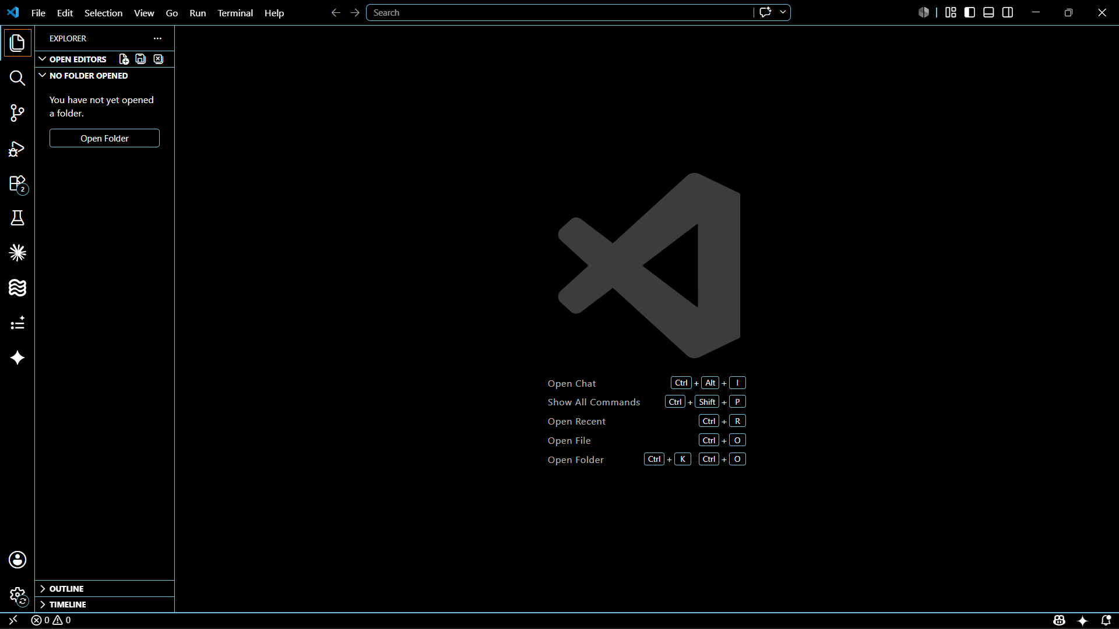

FLUTTER EXTENSION
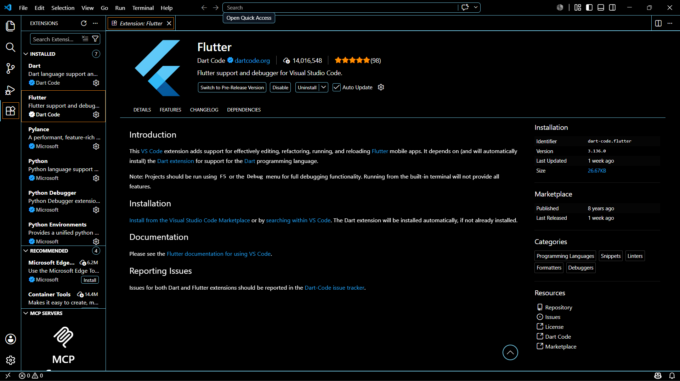

REACT EXTENSION
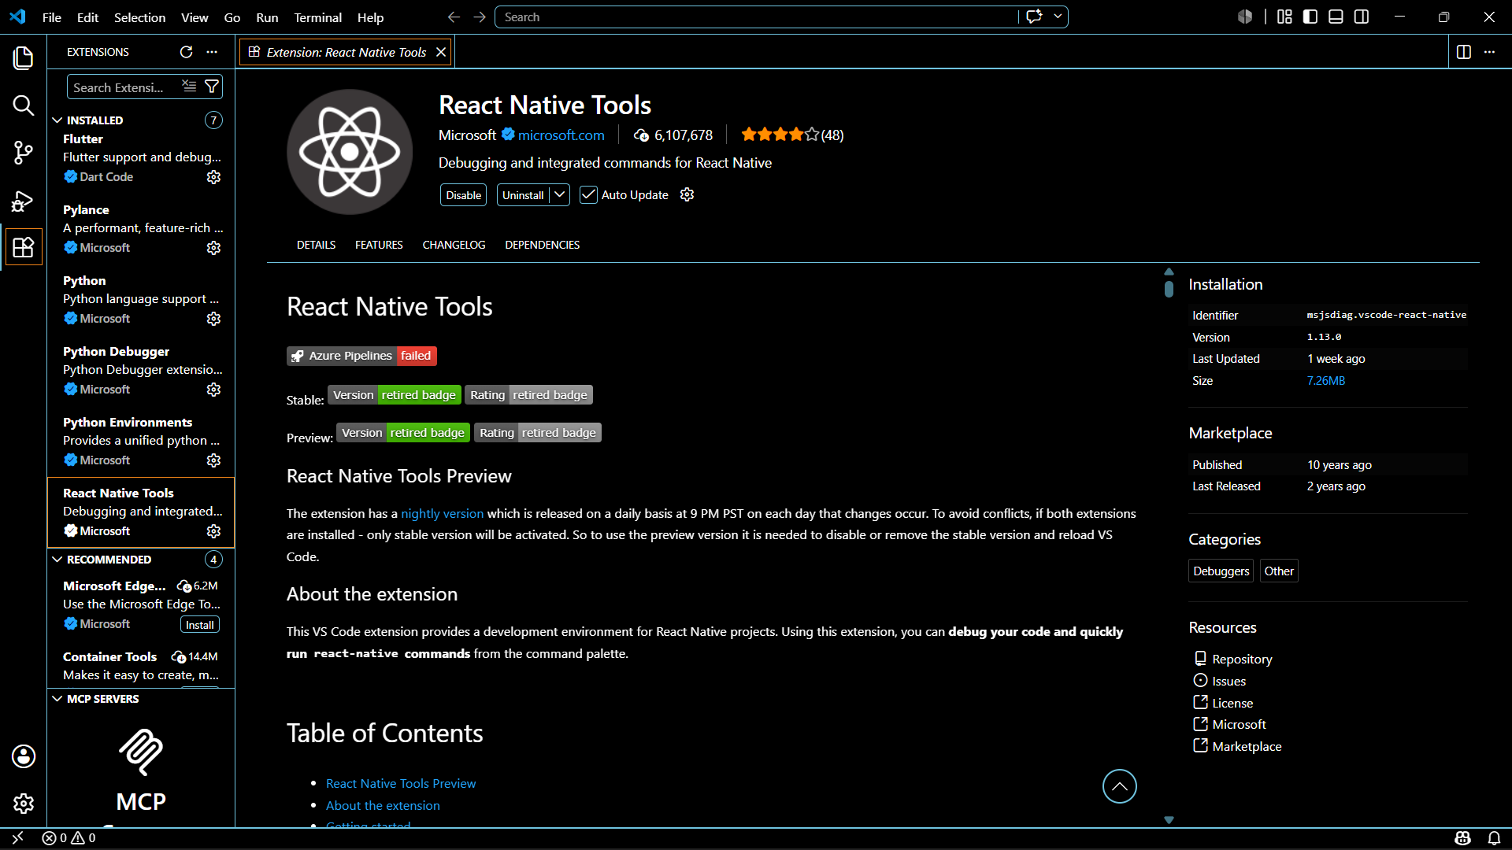

DART EXTENSION
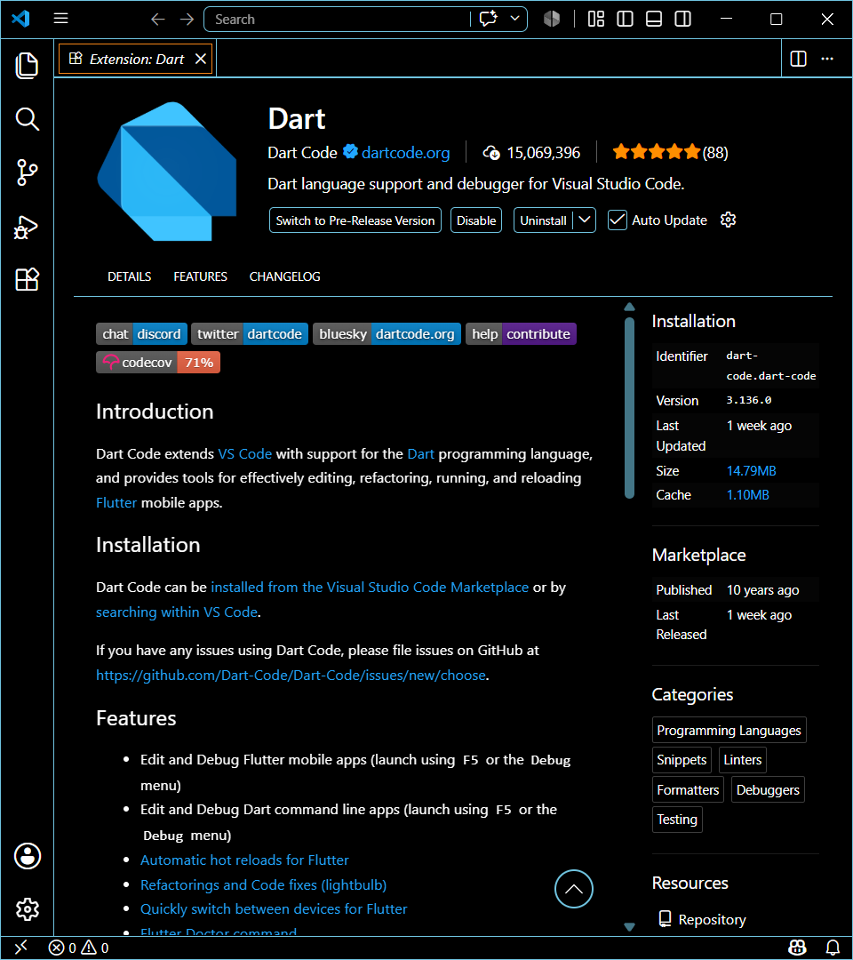

INSTALLATION OF ANDROID STUDO
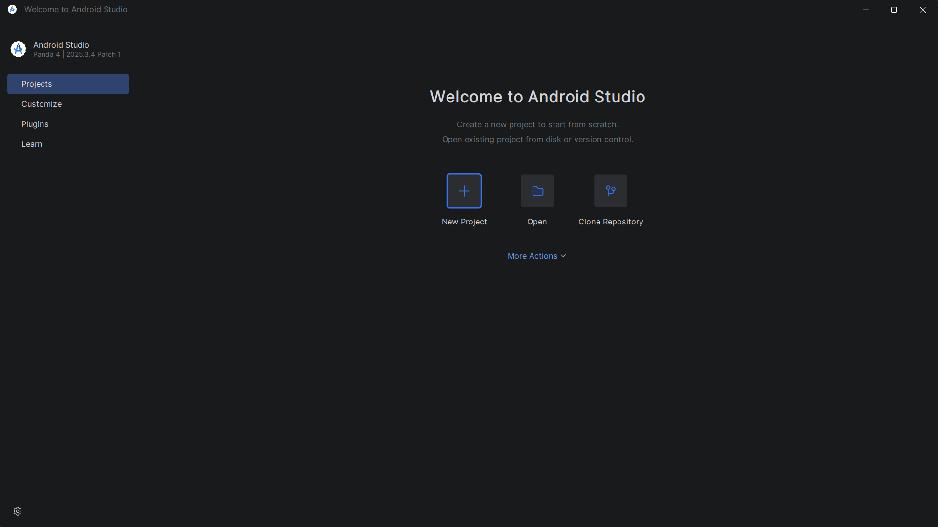

HELLO WORLD DISPLAYED


FIGMA DESIGN OF ADMIN DASHBOARD
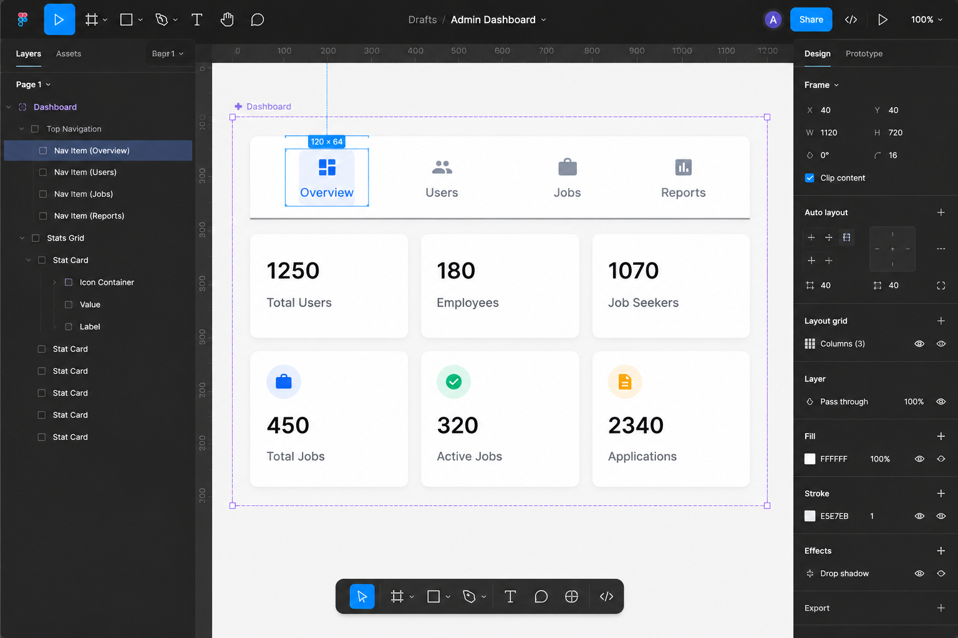

Splash screen
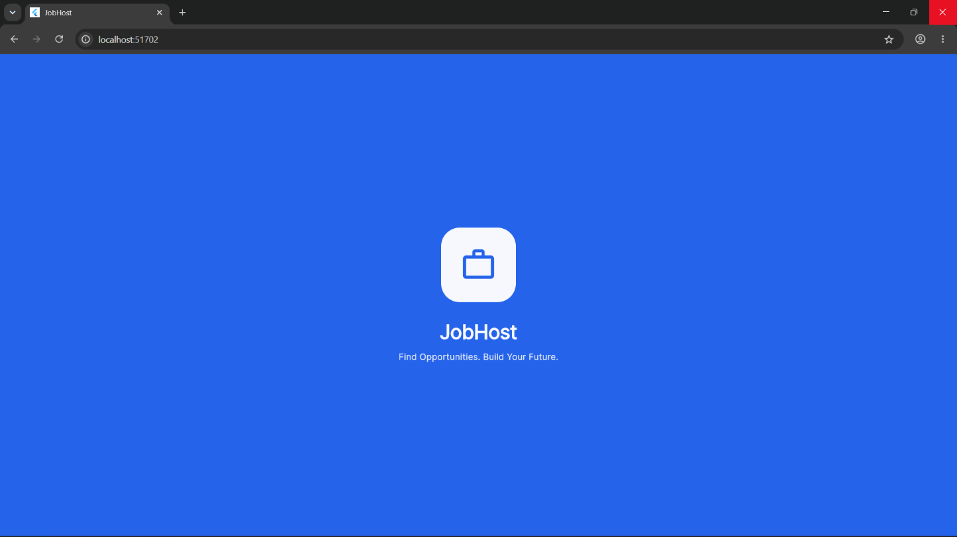

SIGN IN INPAGE

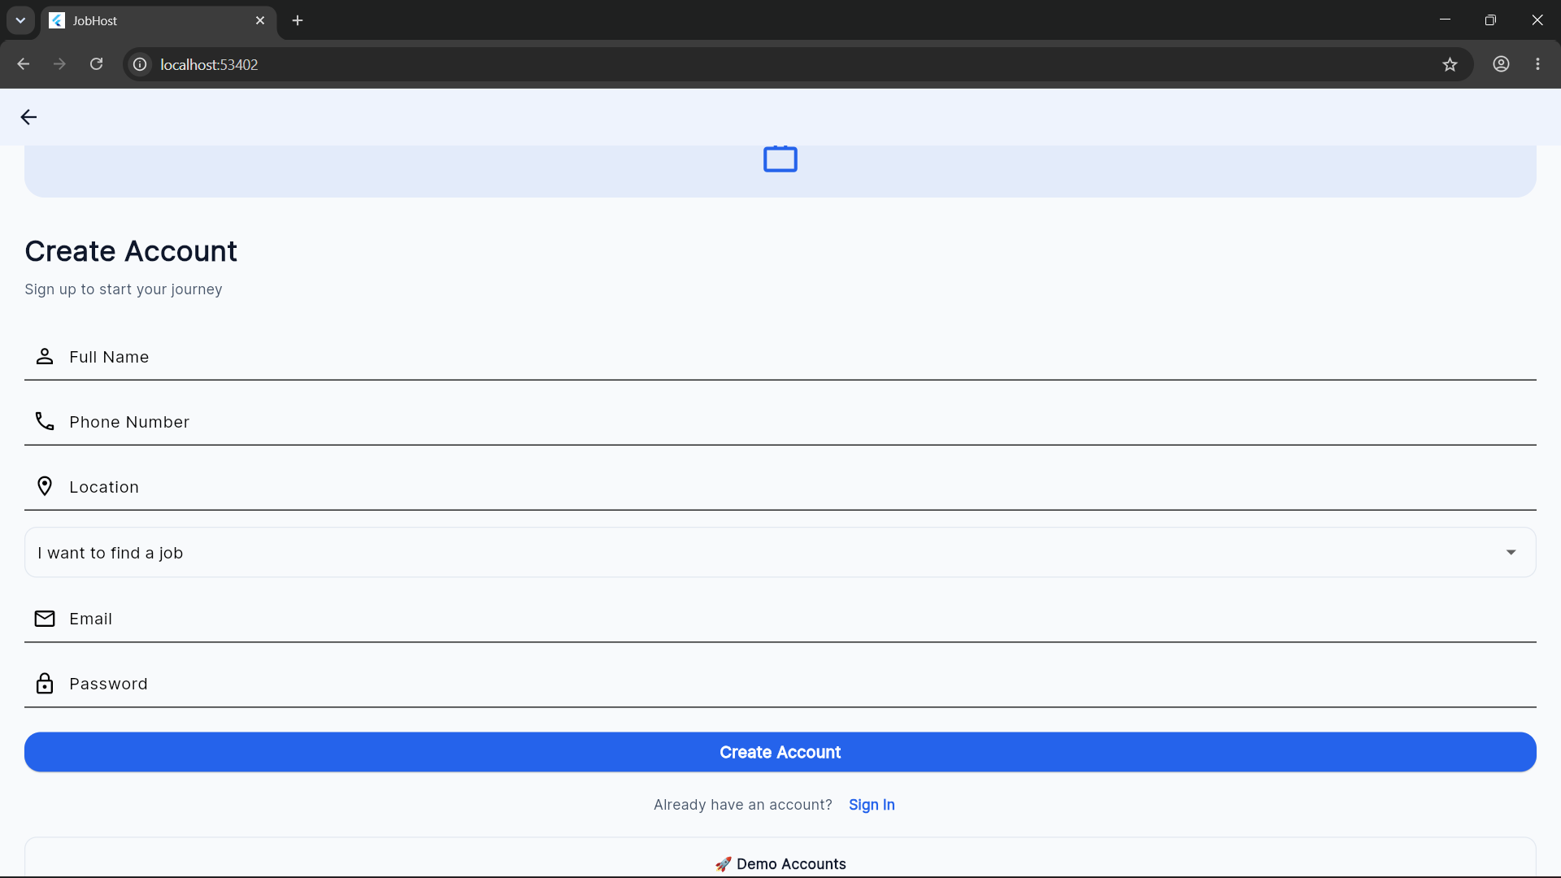
LOGIN PAGE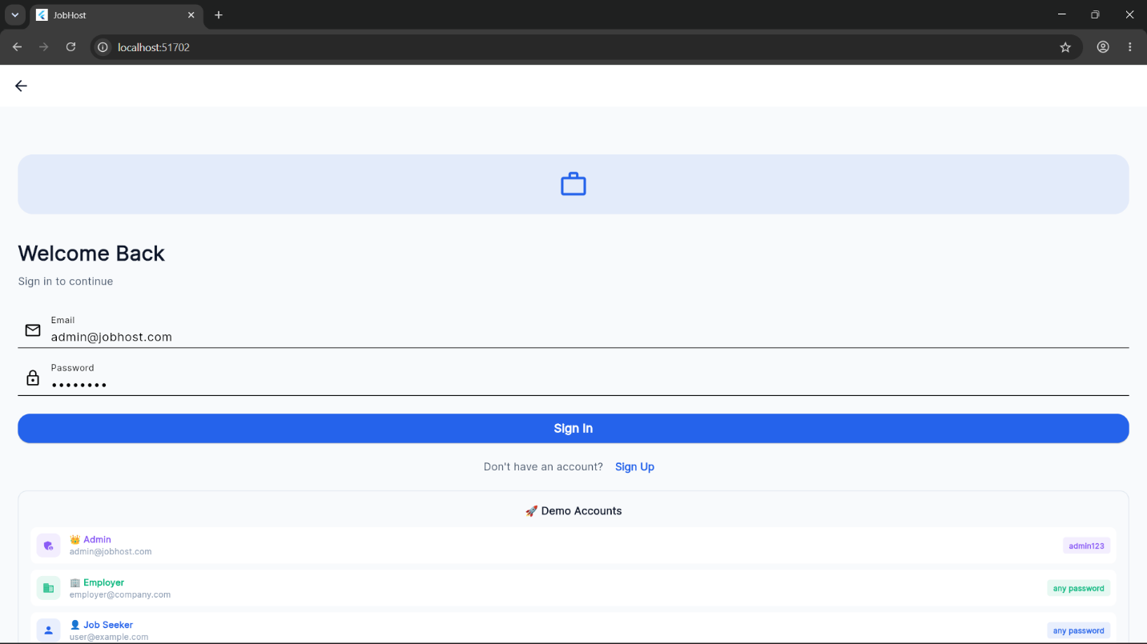

ADMIN DASHBOARD
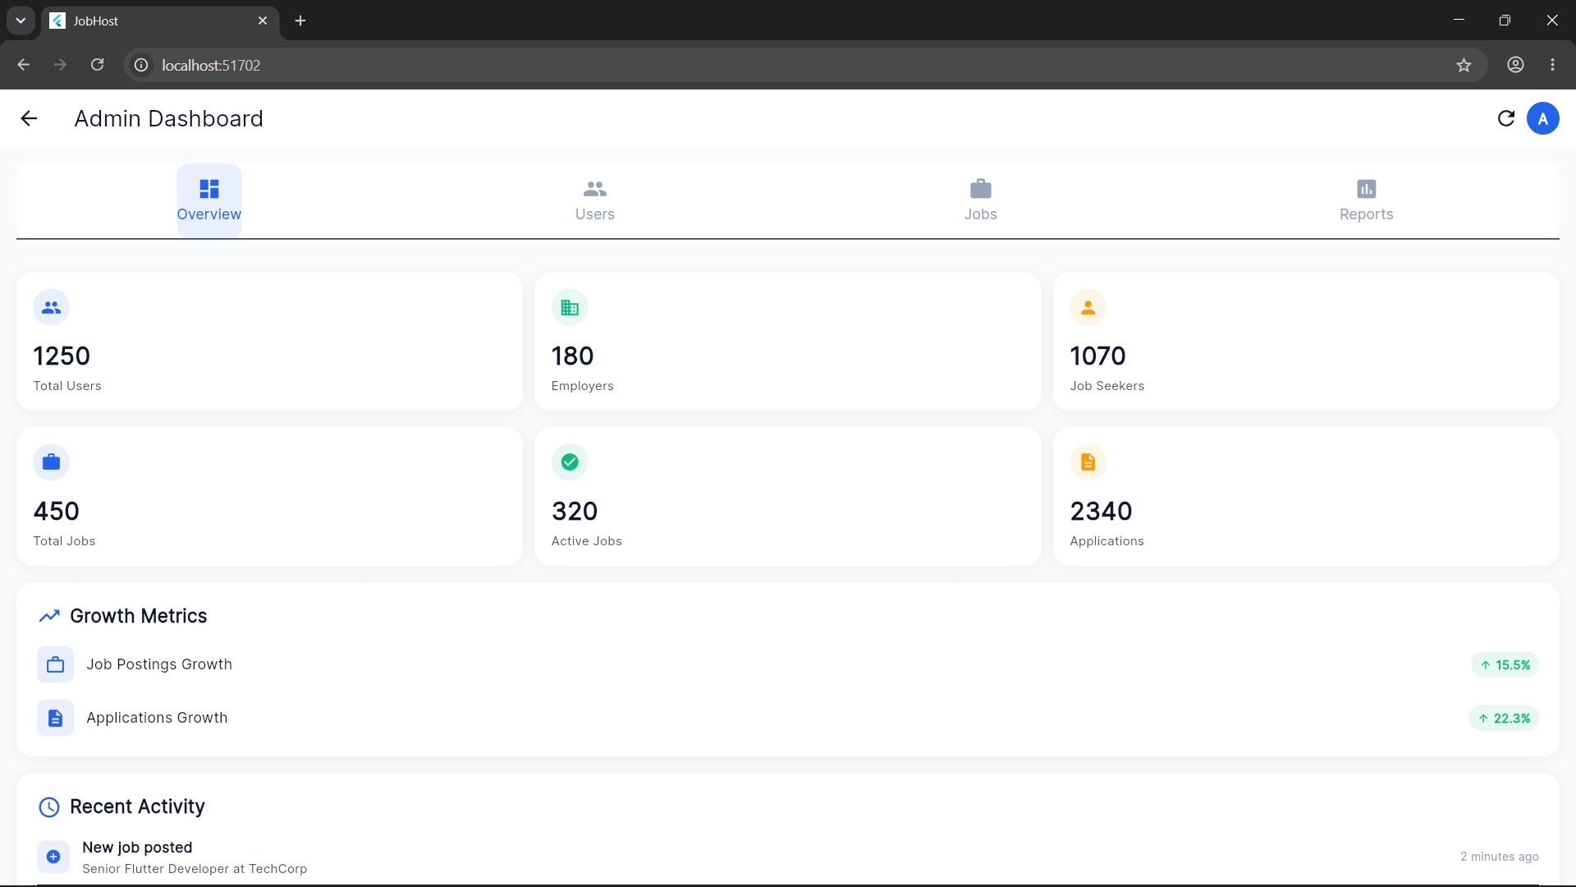

EMPLOYER DASHBOARD
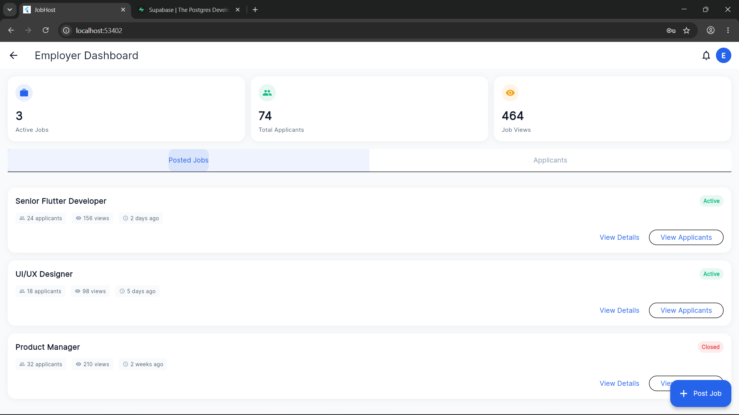

JOB SEEKER DASHBOARD
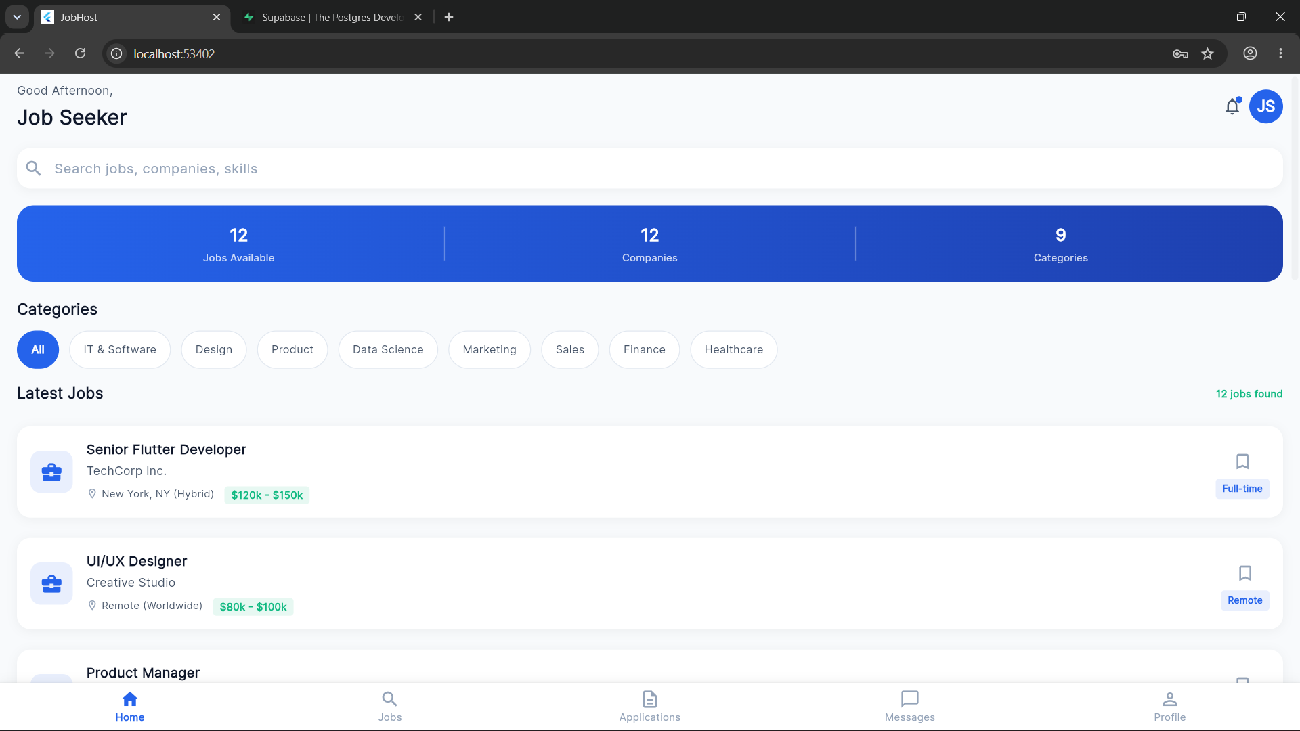

SEARCH JOBS
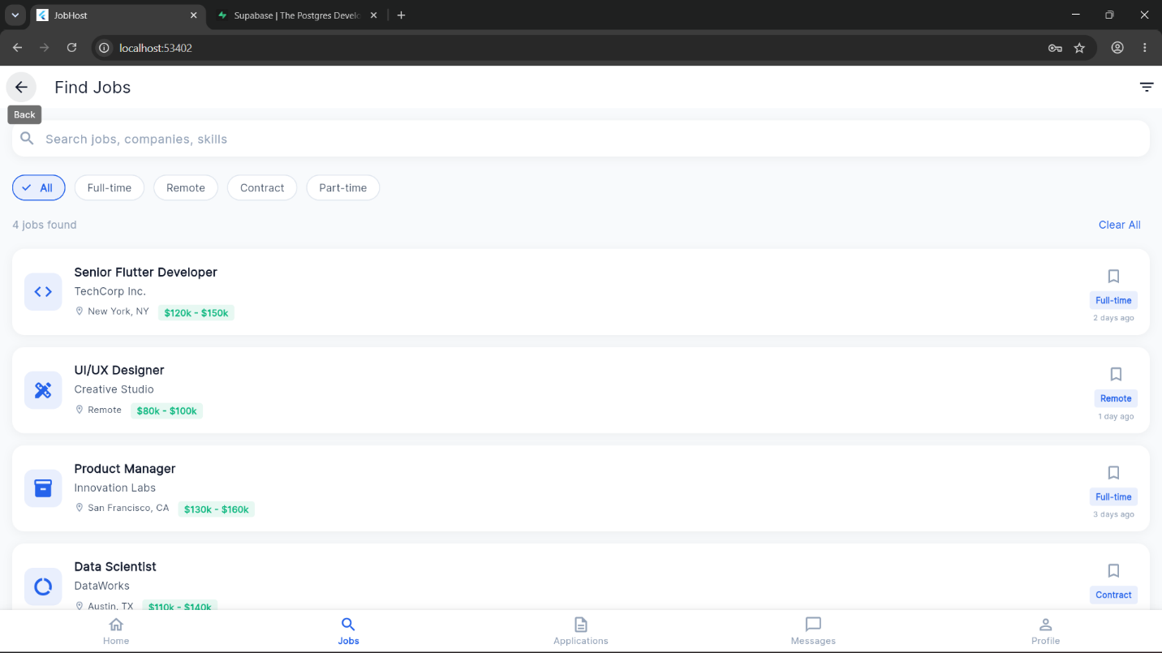

MESSAGES
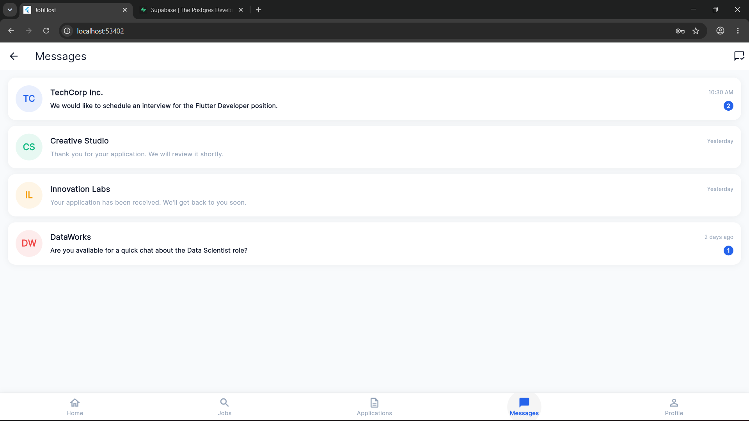

Job posting
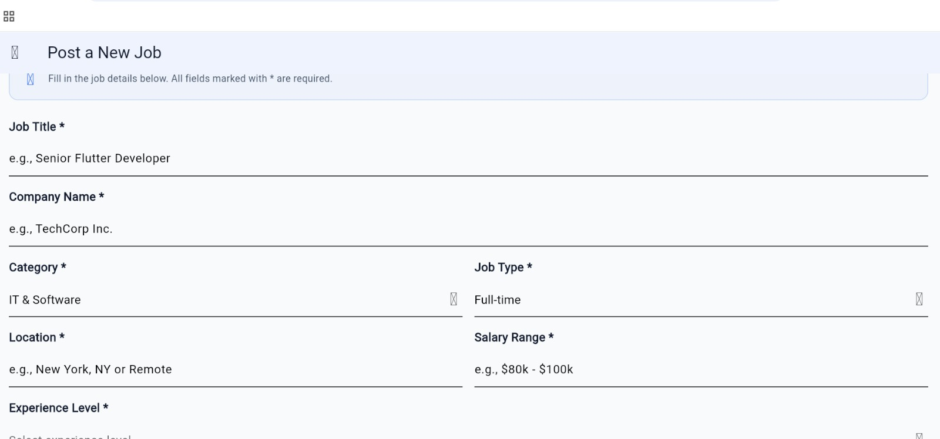

JOB POSTING OUTPUT

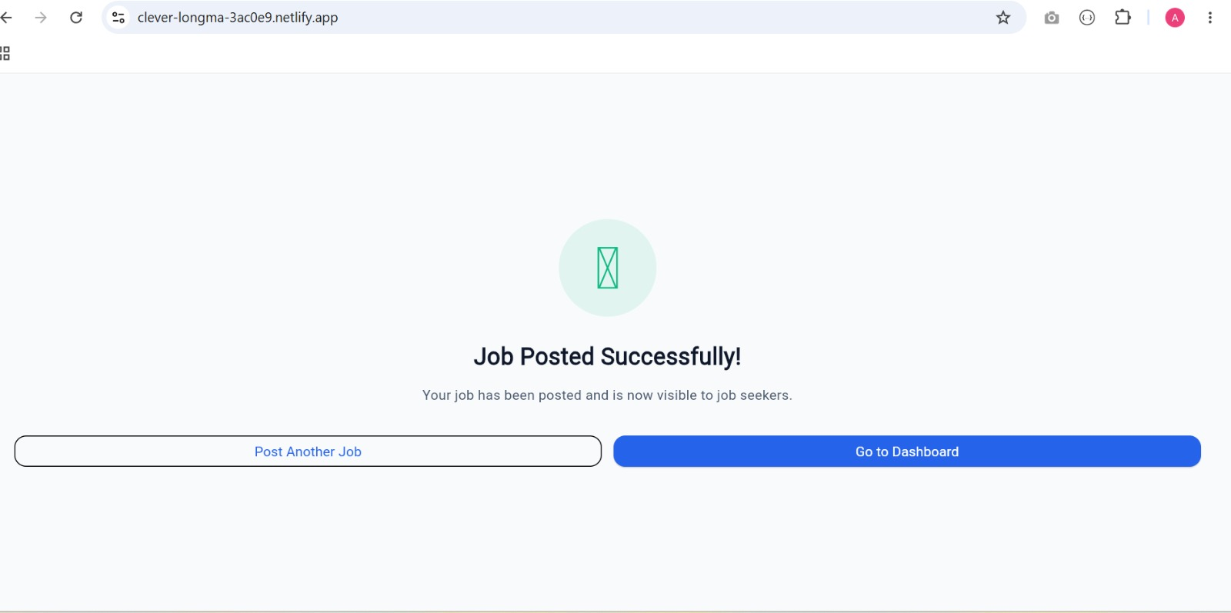

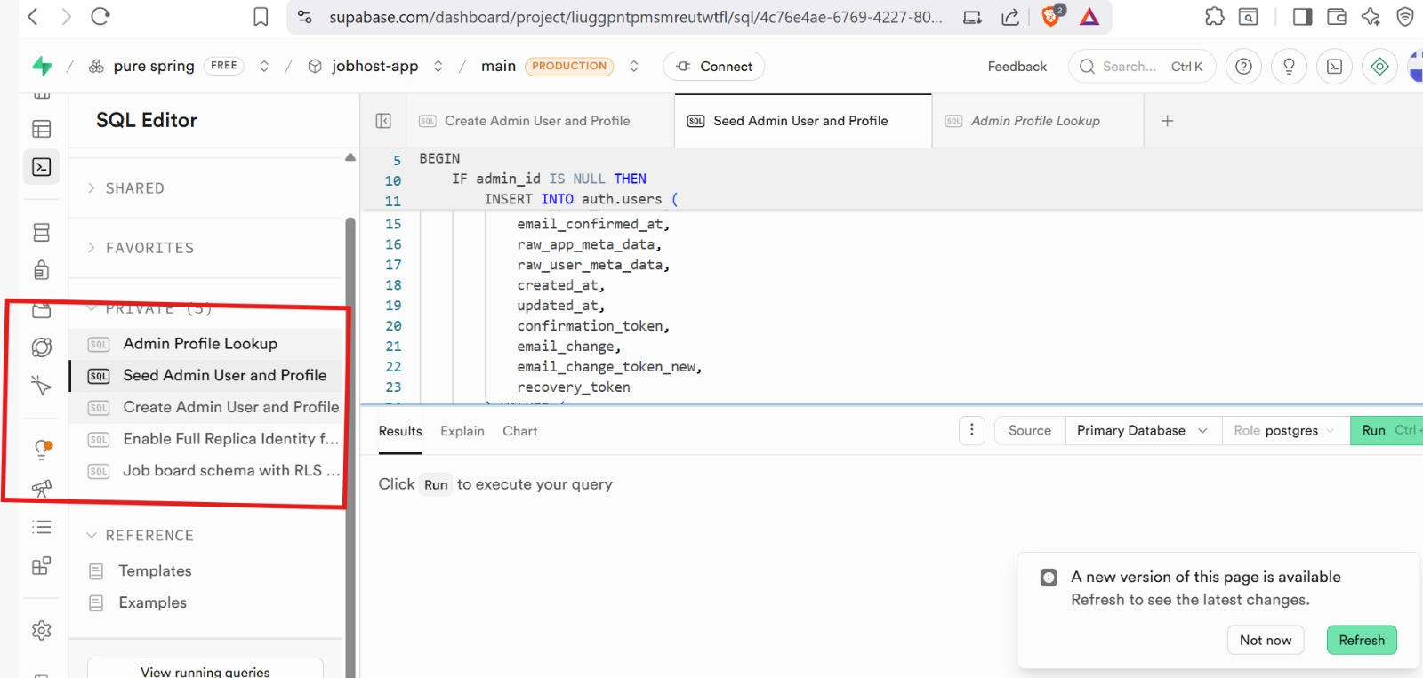
SYSTEM DATABASE

API INTERGRATION
